Staff Training Bundle 1

**JPF First Aid**

**Qualification Training Course Offers**

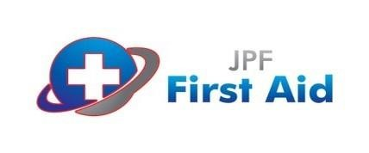

**Staff Training Bundle 1**

**Staff Training Bundle 2**

**Staff Training Bundle 3**

**Staff Training Bundle 4**

*All training bundles

are

for a limited time and

subject to availability. Offers

are based on up to 12 staff

attending on site at your

location or by attending a

venue organised by JPF First

Aid.

Please call 01543 471376

for more details.

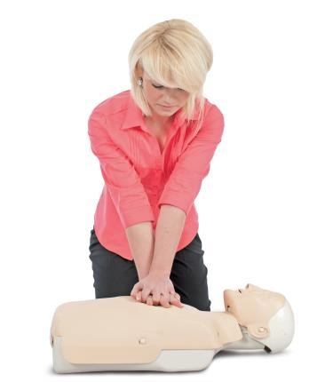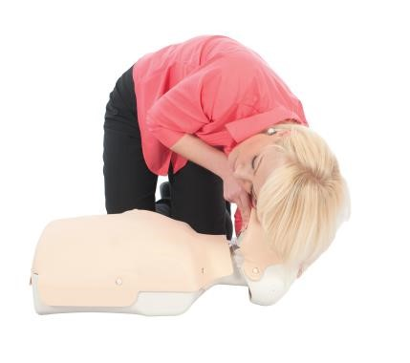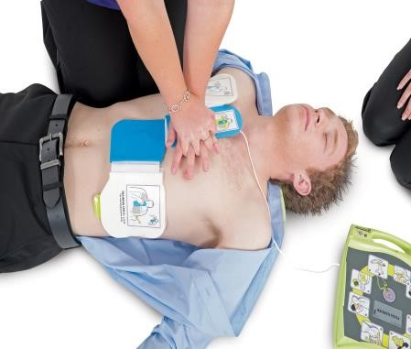

3

-

Day First Aid at Work Course

1

-

Day Manual Handling Course

1

-

Day

Fire Safety Course

All 3 courses for only:

**£1250**

-

On

-

site at your location

o

r

**£1400**

-

Staff to attend

JPF First Aid

1

-

Day Emergency First Aid at Work

Course

1

-

Day Manual Handling Course

1

-

Day Fire Safety Course

All 3 courses for only:

**£820**

-

On

-

site at your location

or

**£970**

-

Staff to attend

JPF First Aid

2

-

Day Paediatric First Aid

Course

1

-

Day Manual Handling Course

1

-

Day Fire Safety Course

All 3 courses for only:

**£1075**

-

On

-

site at your location

or

**£1225**

-

Staff to attend

JPF First Aid

2

-

Day First Aid at Work

Re

-

qualification Course

1

-

Day First Aid Risk Assessment Course

1

-

Day Fire Safety Course

All 3 courses for only:

**£1180**

-

On

-

site at your location

or

**£1330**

-

Staff to attend

JPF First Aid